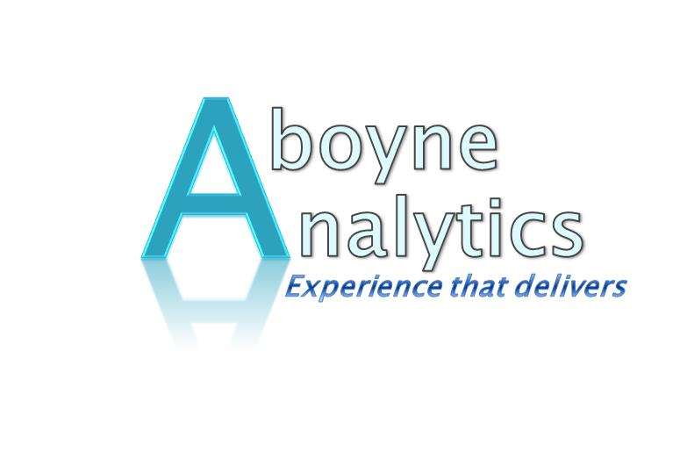
AUSTRALIAN DEFENCE INDUSTRY EXPERTISE
Aboyne Analytics has experience and expertise across Land, Sea & Aerospace with a strong Technology Transfer emphasis enabling the effective manufacture, assembly and test of defence product in Australia
The foundation of this experience and expertise is based on 30+ years in the Australian Defence Industry working with International Original Equipment Manufacturers (OEM’s) setting up a production capability in South Australia as part of Australian Industry Participation requirements. Aboyne Analytics was directly involved in the programs listed below:

- Submarine 1KW Sonar Transmitters – Raytheon USA
- F/A 18 Communications Systems Control Set – Smiths Industries USA
- F/A 18 Stores Management System – Smiths Industries USA
- Collins Submarine Power Conversion Equipment (Maritime) – Euroatlas - Germany
- ANZAC Frigate Combat System Hardware – CelsiusTech Sweden
- P3C Orion Radar Upgrade – Elta Israel
- F/A 18 Laser Ranger/Target Marker - Litton Laser Systems USA
- Collins Submarine Weapons Systems Converter – Singer Librascope USA
- Collins Submarine Periscope – Barr & Stroud UK
- ANZAC Frigate Gun Control Hardware – FMC USA
- Army Perentie Vehicles (Land) - Land Rover UK
- ANZAC Frigate SPS-49 Radar Circuit Cards – Raytheon USA

Phil McAllan, our Director, was also responsible for securing engineering work on Eurofighter Synthetic Training Aid Software (Aerospace) – BAE Systems UK as well as Unmanned Aerial Vehicle (UAV) Flight Control Software Modules – BAE Systems UK.
The Nulka Decoy Project – a joint US Navy/Australian Project - provided significant experience in managing a multinational Joint Development Project with International Customers.
The Technology Transfer knowhow translates very well into transferring best practice across both operational and functional elements of any business.

