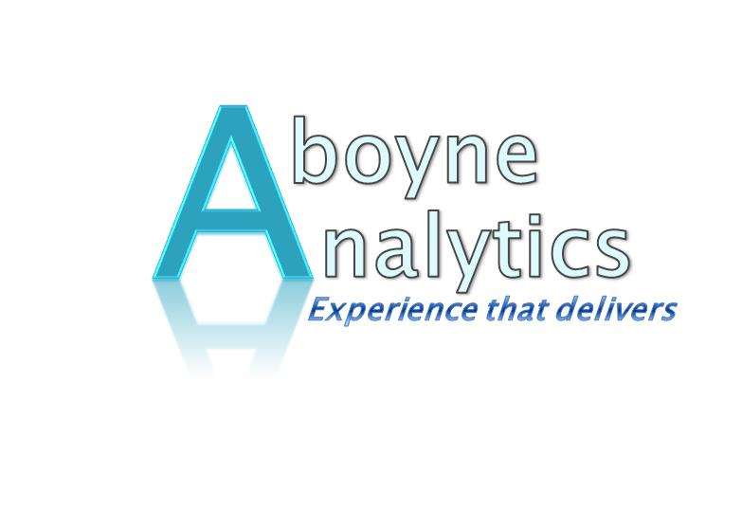
BUSINESS TRANSFORMATION & CHANGE MANAGEMENT
Aboyne Analytics has experience and expertise across both functional (corporate) and operational business transformation / change management programs.
The foundation of this experience and expertise is based on over 20 years of business transformation/change management projects. Three examples of significant Business Transformation/Change Management Projects are provided below. :

- IM&T Transformation/Change Management - December 11 to June 15 - Cost Reduction with improved performance - 27% headcount reduction while improving performance and employee engagement – The Employee Opinion Survey (EOS) was undertaken across BAE Systems global by IBM Consultants Kenexa. Not only did IM&T have significant improvement but exceeded the global Norms of High Performing Teams.
 | 2013 | 2014
Management creates an environment of openness and trust | 38% | 80%
I have a clear understanding of what is expected of me | 75% | 95%
My Immediate manager/supervisor does a good job at building the team, recognising achievement etc. | 63% | 83%
I can see a clear link between my work and our company’s strategy | 38% | 91%

- Business Assurance Transformation/Change Management – April 09 to October 10 – Following the Tenix/BAE Systems merger integrate 5 standalone Quality Management Systems (QMS) into one Business Management System (BMS). The outcome was a “single source of truth” having multiple views of content with a powerful search engine. This enabled the streamlining of business process through an effective Business Process Council (BPC) governing BMS content. Deployment of an Operational Framework ensuring compliance to global governance requirements was included in this transformation.

- Military Vehicles Transformation/Change Management – April 96 to August 97 – Over a twelve month period transformed the Perentie vehicle production line from Defence Quality Assurance (DQA) threatening to remove ISO 9001 accreditation to the Customer Program Director commenting that the vehicles were the best he had ever seen presented for acceptance. The transformation involved reducing headcount, streamlining production processes and restructuring the production work teams/cells.

